USDA Fruit Quiz (From http://www.choosemyplate.gov/fruitquiz_start)
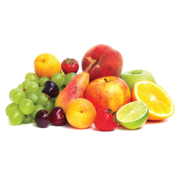
Which of these nutrients can you get from eating whole fruit that is not usually found in juice?
Vitamins
Minerals
Fiber
Sugar

Potassium is a nutrient that many Americans don’t get enough of. Which of the following is a good fruit source of this mineral known to help regulate blood pressure?
Dried apricots
Bananas
Orange juice
All of the above

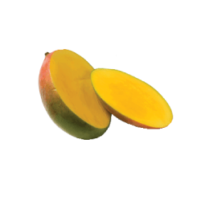
Which fruit is this?
Cantaloupe
Papaya
Mango
Star fruit
Moon fruit
Eating a diet rich in fruits and vegetables as part of an overall healthy diet may protect against certain types of cancer.
True
False

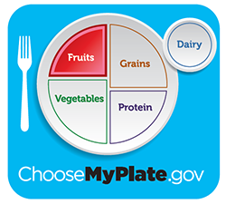
Which of the following counts as part of the Fruit Group?
Canned peaches
Dried apricots
100% orange juice
Fresh strawberries
All of the above

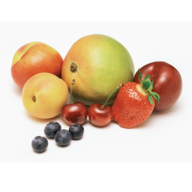
Fiber found in fruit is associated with which of the following health outcomes?
Strengthening bones
Maintaining proper bowel function
Building muscle
Making new blood cells

Fruits are sources of which of the following?
Folate
Vitamin D
Calcium
Protein

Which of these foods is actually a fruit in plant biology?
Onion
Pepper
Mushrooms
All of the above
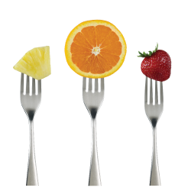
Which of these foods is a source of vitamin C?
Pineapples
Strawberries
Oranges
All of the above

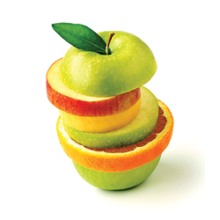
What do fruits have that make them sweet?
Vitamin C
Fiber
Fructose
Protein
Pleasing or agreeable personalities

