USDA Vegetable Quiz https://www.choosemyplate.gov/quiz-index

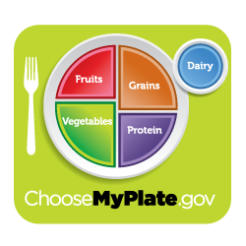
About how much of your plate should be fruits and vegetables?
One quarter
One half
Three quarters
All of it
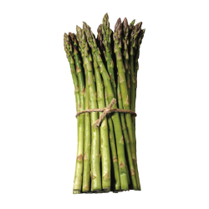
What are these?
Scallions (spring onions)
Asparagus spears
Broccoli spears
Britney Spears
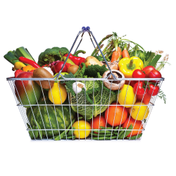
Eating a diet with lots of vegetables and fruit is good for you.
True
False

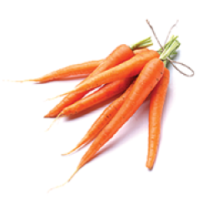
What vitamin gives carrots and sweet potatoes their orange color?
Vitamin D
Folate
Vitamin A
Vitamin O
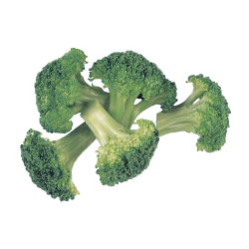
Which of these is a subgroup of vegetables?
Raw
Crunchy
Dark-green
Juiced

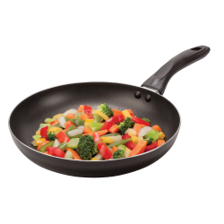
You should only eat raw vegetables because if you cook vegetables, all of the vitamins are “cooked away.”
True
False

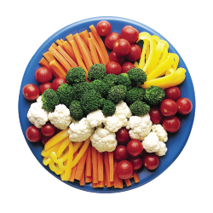
What color vegetable should you eat the most?
Orange, because they taste the best
Purple, because they are rare and exotic
Green, because kale is green
A variety of colors

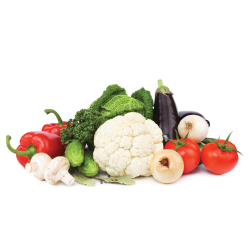
Which of these foods is actually a fruit in plant biology?
Tomatoes
Sweet onions
Peas
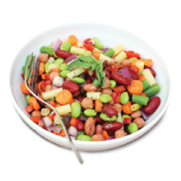
Kale

What food group are beans and peas counted in?
Vegetable group
Protein group
Both
Neither
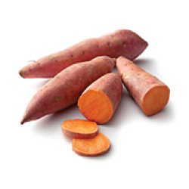
Carrots, onions, and sweet potatoes are all vegetables and are what part of a plant?
Seeds
Flower
Root
Stem

