No Cook cooking cookbook
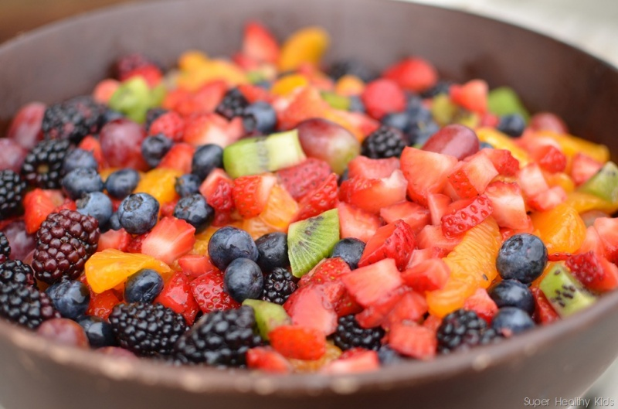
Fruit Salad- an excellent way to get Vitamins, Minerals and Fiber
Recipes from our No Cook Cooking Class
Fall 2015

Class #1 Fruit Salad

You will need:
A Mixing bowl
A Large Spoon
A knife to cut with
A Cutting board
3-5 kinds of fruit of your choice.

Step 1. Shop for your favorite Fruits
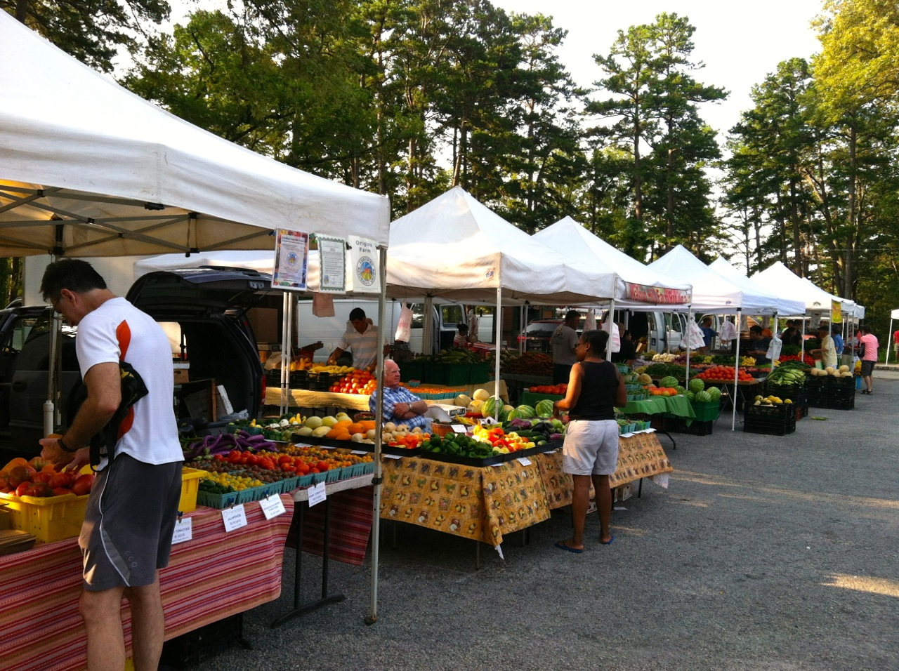

Step 2. Wash Fruits
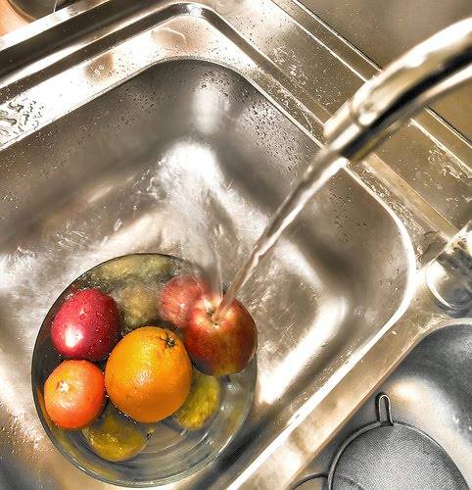
Step 3. Cut up your fruit.
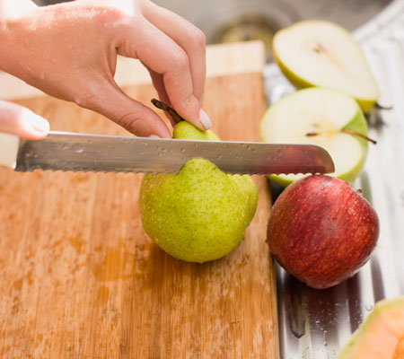

Step 4. Put Fruit in the bowl and gently mix.
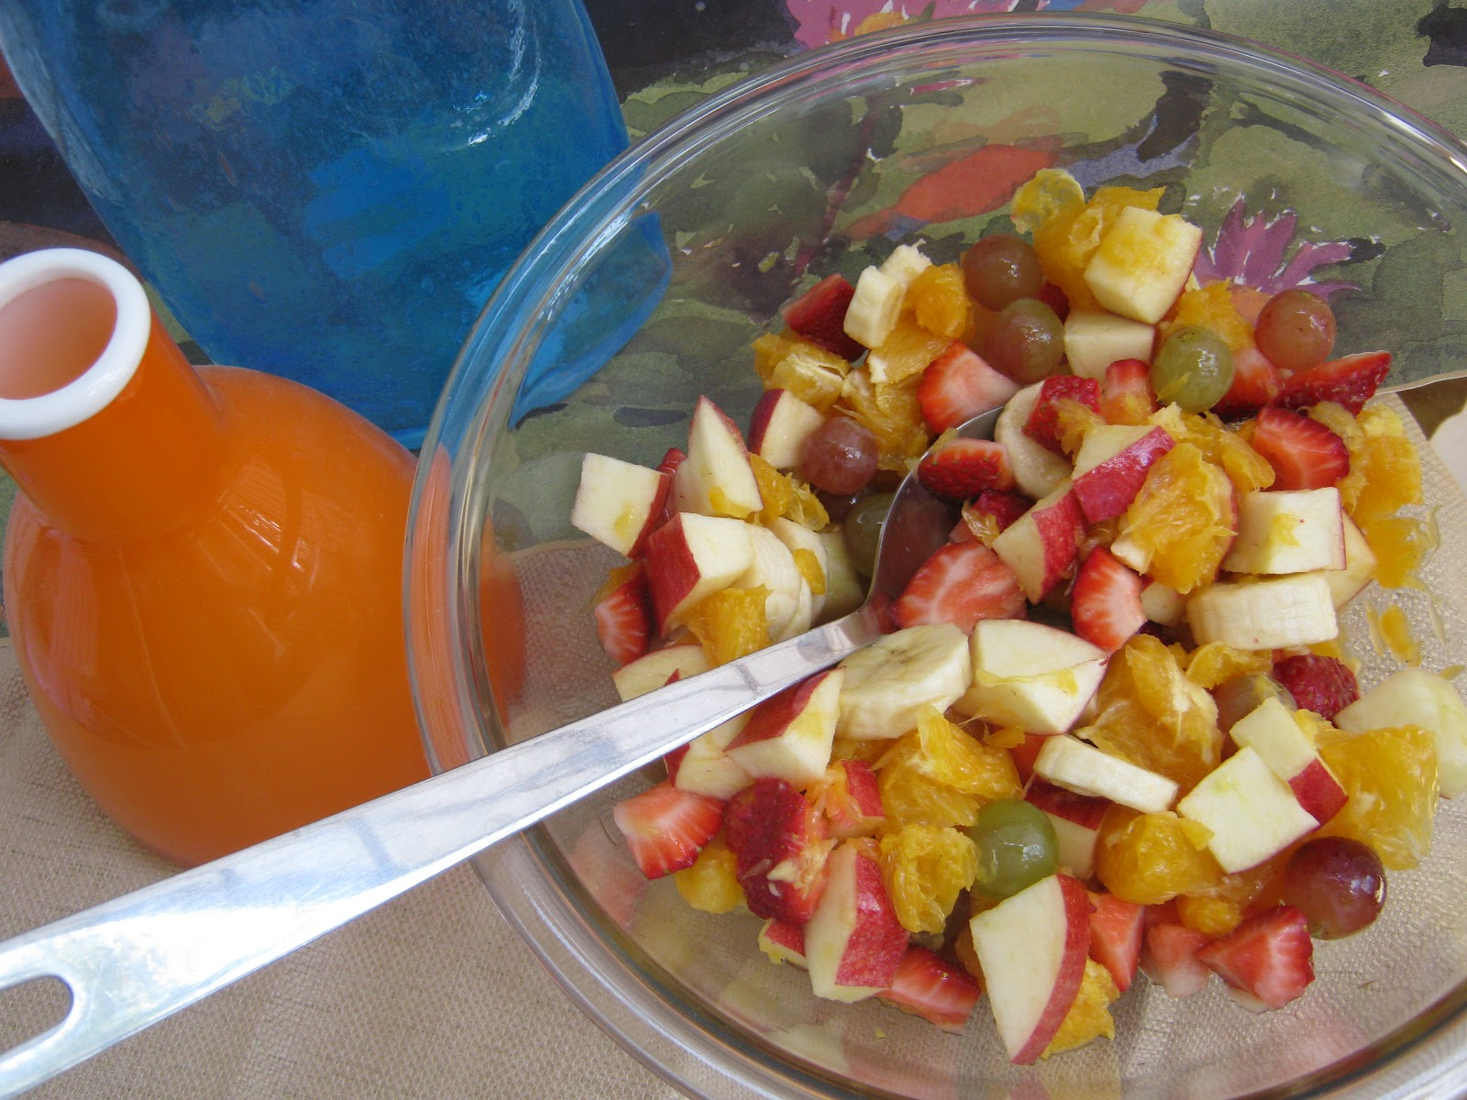

Step 5.
ENJOY (Share with friends!)
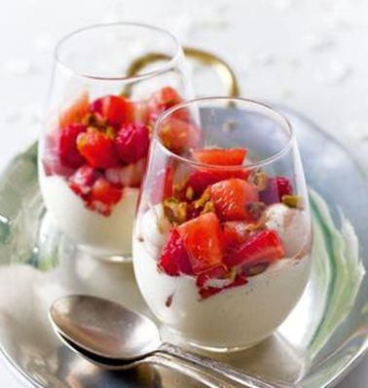

You can also serve it on top of yogurt and Granola, or store some in containers in your freezer for future Smoothies.

Class #2
Hummus

You will need:
1 can Garbanzo Beans
4 Cloves of Garlic
2 tablespoons Olive Oil
1 Lemon
1/3 cup Tahini (Sesame Seed Paste)
A Cutting Board
A strainer or Colander
A pinch of Salt
A can opener
A serving bowl
A spoon or spatula
A Blender or Food Processer

Step 1. Open the can of Beans and rinse in a Colander or Strainer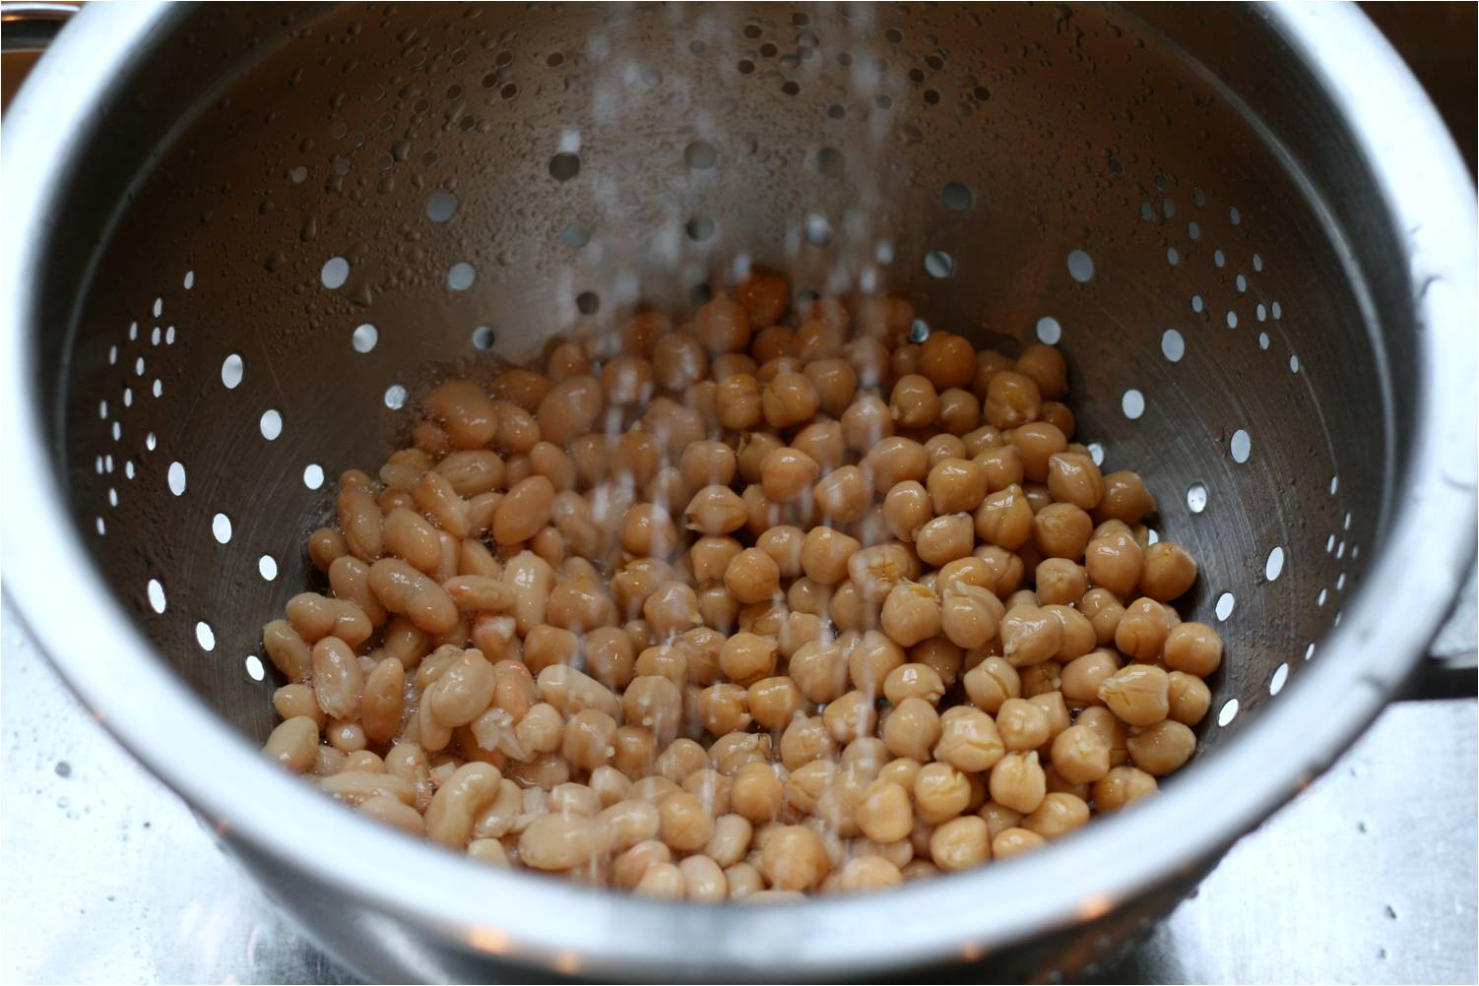

Step 2. Peel the Garlic.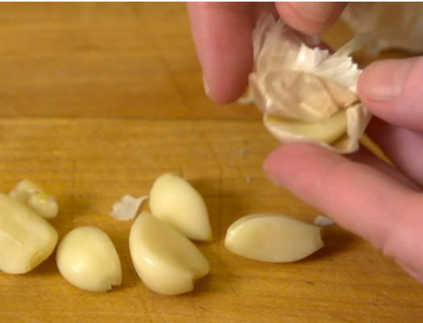

Step 3 Cut up the lemon and squeeze the juice. Use a strainer to catch the seeds.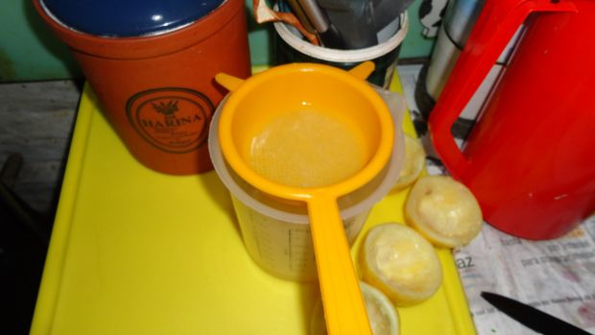

Step 4. Put all ingredients into the Food Processor or Blender
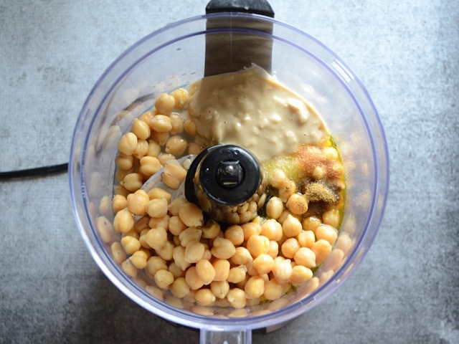

Step 5. Blend until smooth.
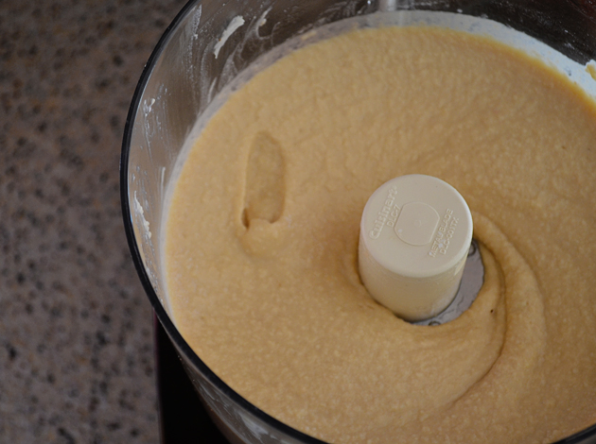

Step 6. Put in serving bowl and serve with Chips, Crackers or sliced vegetables and share with friends or use as salad dressing.
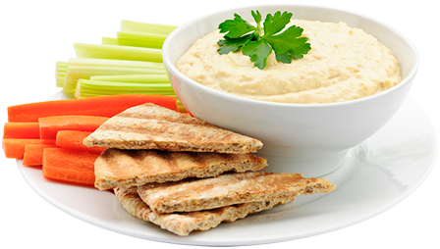

Class # 3 Salad with Balsamic Vinaigrette

You will need:
A Large Mixing bowl
Colander
Dark Leafy greens (Lettuce, Kale, Spinach, Arugula, or spring mix)
An Apple, or other fruit
or vegetables (Cucumber, Onion greens, bell pepper, carrots or broccoli for example)
Toasted nuts (Optional)
Dressing:
a small jar for mixing dressing
¼ cup Balsamic Vinegar
¼ cup Olive Oil (or sesame oil)
A pinch of salt, and pepper to taste
Italian Seasoning
Step one. Wash the vegetables.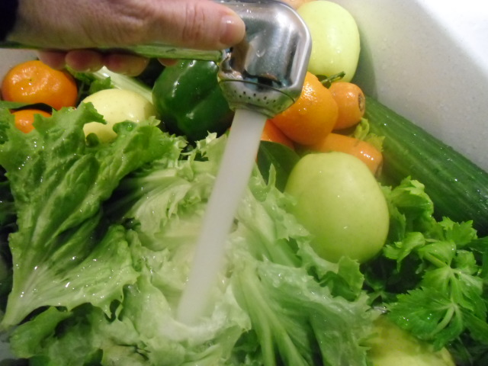

Step 2. Cut vegetables into bite sized pieces.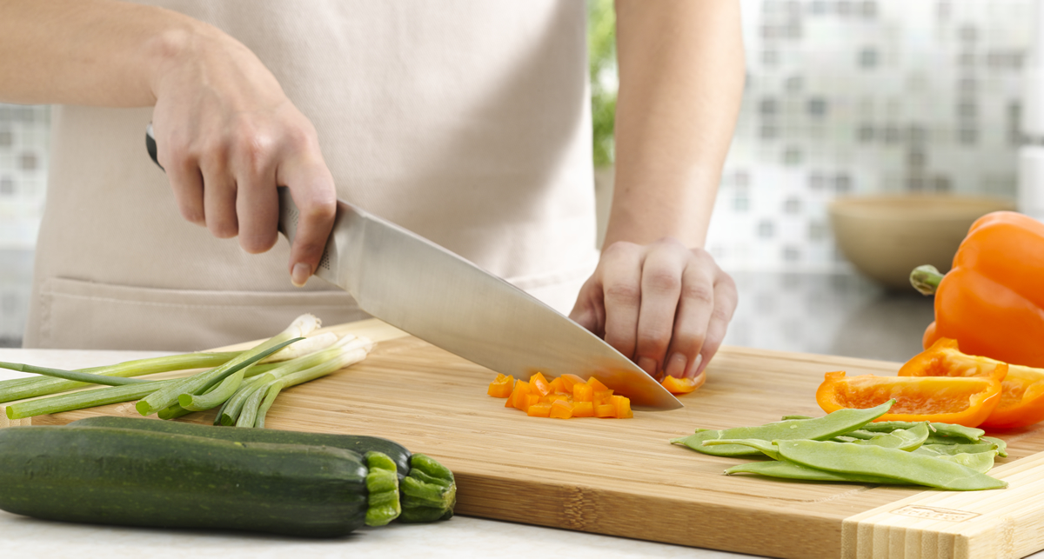

Step 3. Toss all vegetables together in a bowl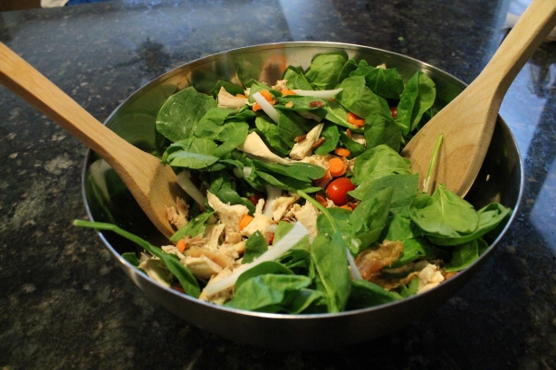

Step 4. Put all ingredients for the dressing in a small jar. Put the lid on well and shake. Pour over salad. Toss gently so the dressing evenly coats the salad.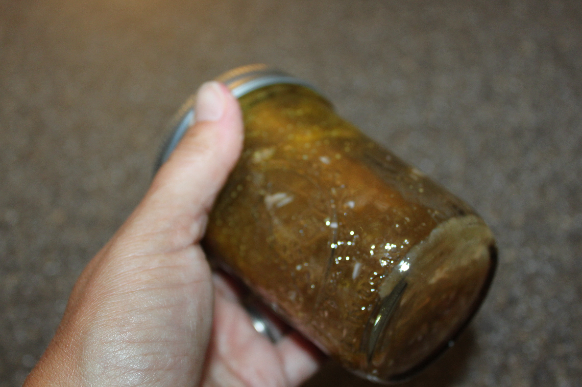
Step 5. Serve and ENJOY!!

Class #4. Aram Sandwich rolls

You will need:
Large flour Tortillas
1 tablespoon Cream Cheese.
Lettuce
Tomatoes, sliced thinly
Cucumbers, Sliced thinly.
2 slices of Turkey Lunchmeat
A cutting board and Knife

Step 1. Lay down your Tortilla on the cutting board.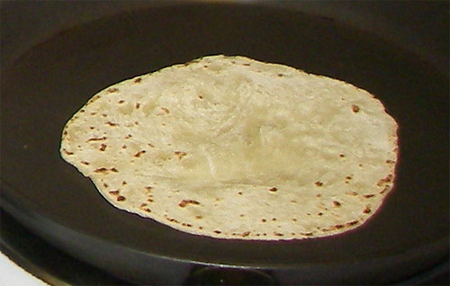

Step 2. Spread Cream cheese on ½ of the tortilla, closest to you.
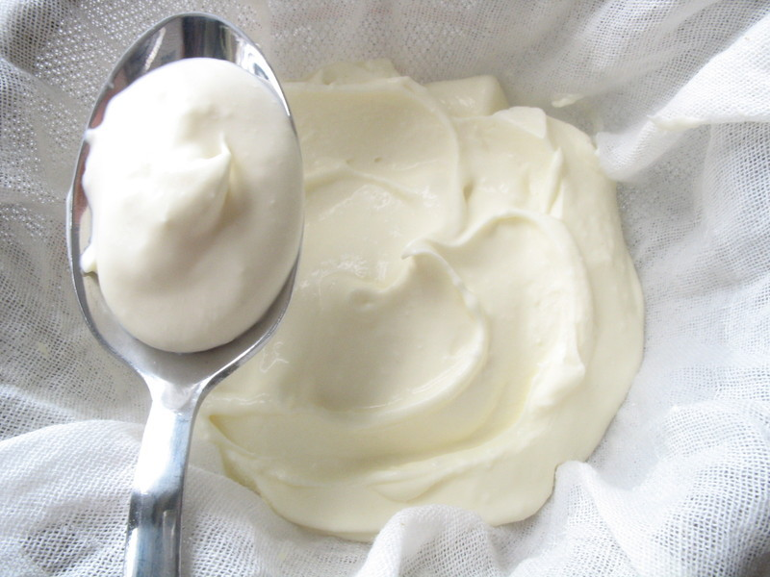

Step 3. Layer all the other ingredients `
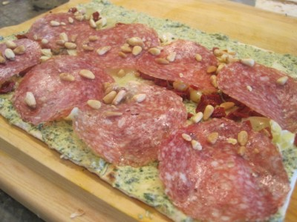

Step 5. Roll the sandwich up
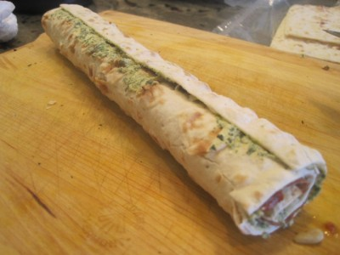

Step 6. Cut into slices and enjoy!
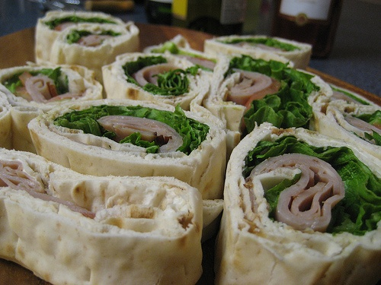

Class # 5 Stuffed Medjool Dates

You will need:
2-4 Medjool dates per person
4-8 Pecan, Walnut halves per person
1 Package of Chevre Cheese
1 Bunch fresh Mint Leaves
A knife
A cutting board
A teaspoon

Step 1. Cut the dates in half and remove the pit.
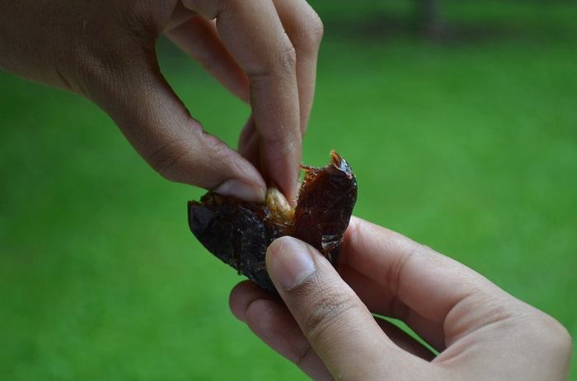

Step 2. Fill each half with a small spoonful of Chevre Cheese, about 1 teaspoon per Date.
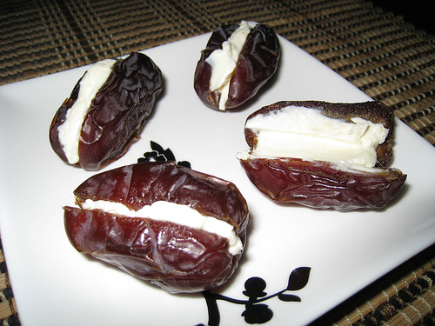

Step 3. Place a mint leaf and a nut on top of each Date. (Leave off the nuts if you are allergic!)
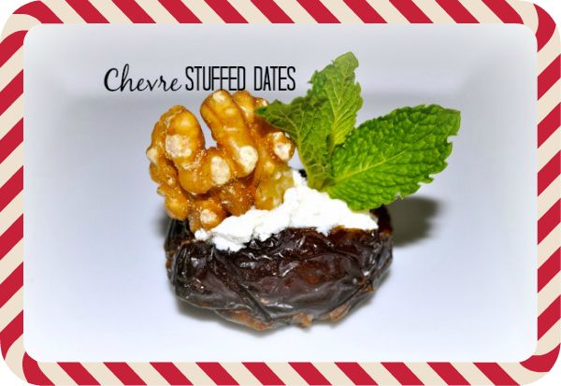
Enjoy no more than 3-4 per person as dates are very high in sugar and fiber. ) Great paired with Mint Tea.

Class #6. Smoothies

You will need:
A blender
2-3 fruits such as Bananas, Berries, pears or apples
2-3 veggies such as Kale, Dandelion leaves, Carrots, or Cucumber
Yogurt (Optional)
Ice (Or you can use some frozen fruit)

Step 1. Put any leafy greens into the blender first and blend on high with the ice (or frozen fruit).
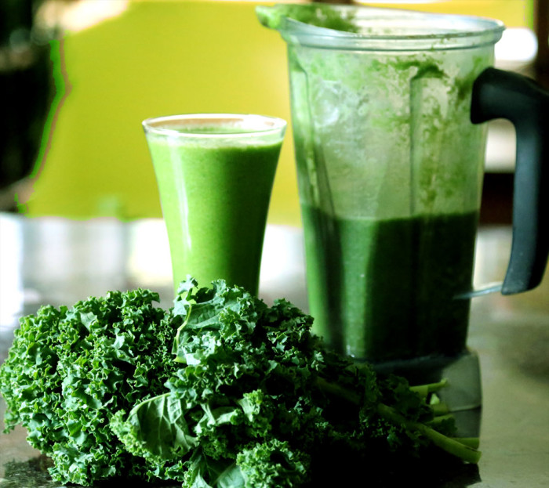

Step 2. Roughly chop up remaining fruits and veggies (and Yogurt if you are using some) and add them to the blender. Blend on high until smooth.
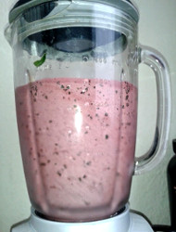

Pour in glasses and enjoy!

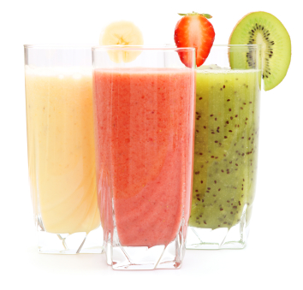
Class #7 Caprese Kabobs

You will need:
Skewers
Cherry Tomatoes
Basil Leaves
Mozzarella balls
A little Olive Oil or Italian dressing

Step 1. Slide a tomato onto a skewer

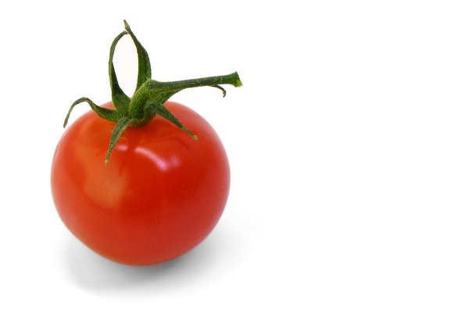

Step 2. Slide a leaf of Basil on to the Skewer.
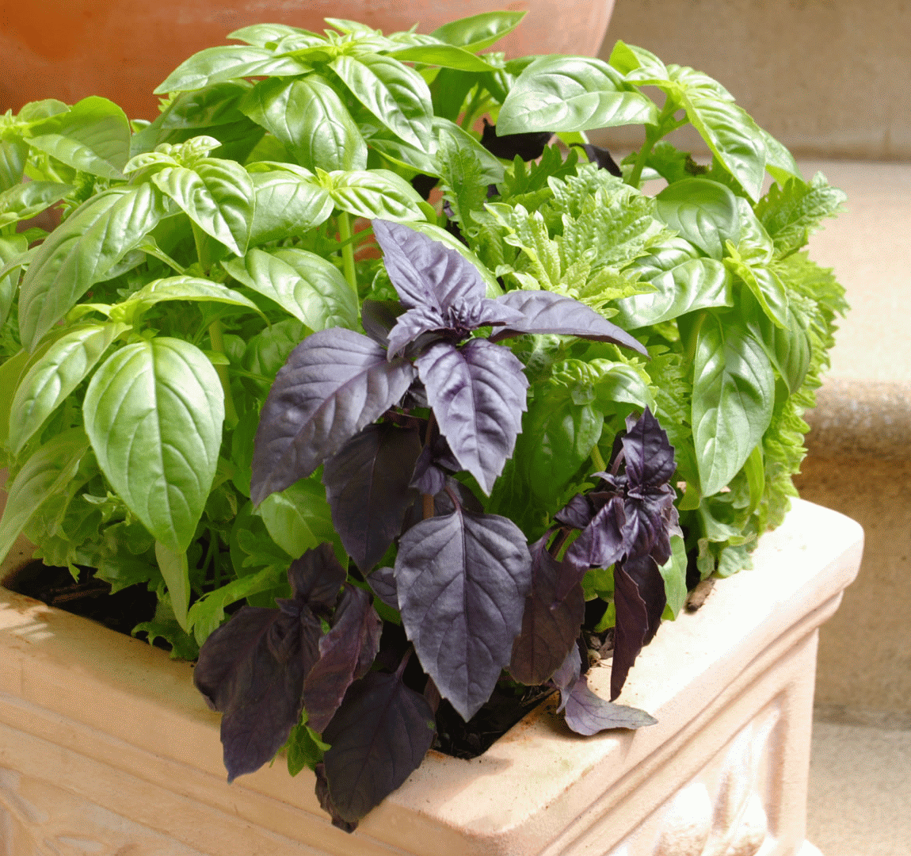
Step 3. Slide a ball of Mozzarella onto the skewer.
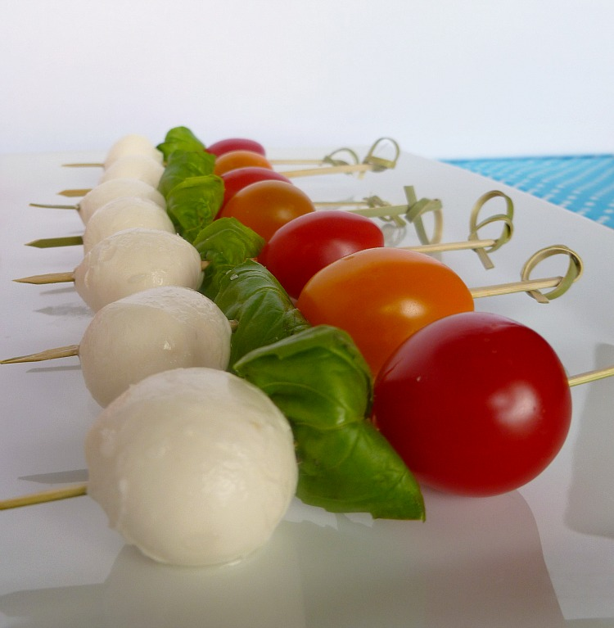
Step 4. Repeat steps 1-3 until the Skewer is full. Drizzle Olive oil or Italian dressing on top.
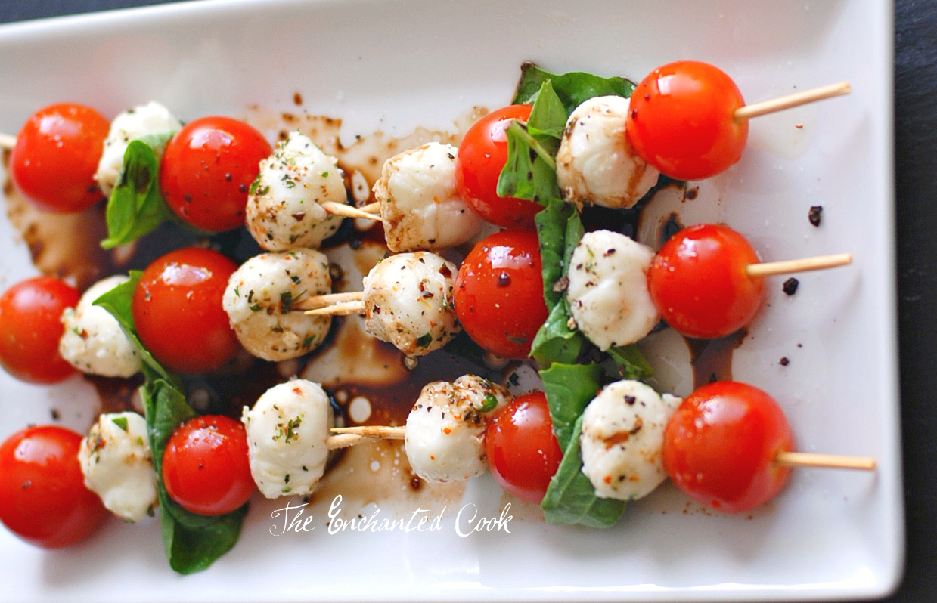
Enjoy!

